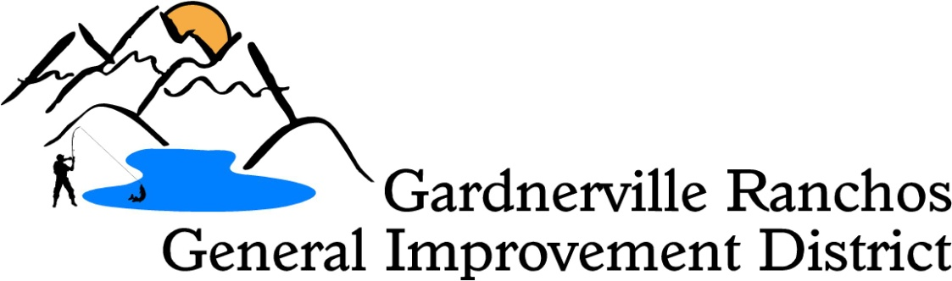

Posted March 16, 2020

Workshops

The previously scheduled workshops for March 18th and 19th 2020 will be rescheduled. A new Agenda will posted be accordingly.

Agendas are posted at the District Office, DCSO Substation Tillman Center, Scarselli Elementary School, C.C. Meneley Elementary School, 7-11 on Tillman Ln. and on the World Wide Web at www.grgid.com. The amount of time given for each item on this agenda is approximate.

Copies of the canceled agenda notice were posted at _____: pm on
___________________on _________________, _____________________________

Signed___________________________________________

